<Image Gallery Software>

Use-Case Specification: <Chat Global>

Version <1.0>

Revision History

|  |  |  |  |
| --- | --- | --- | --- |
| **Date** | **Version** | **Description** | **Author** |
| <dd/mmm/yy> | <1.0> | <details> | Nguyen Kiem Hoa |
|  |  |  |  |
|  |  |  |  |
|  |  |  |  |

Table of Contents

1. Chat Global 4

1.1 Brief Description 4

1.2 Actor 4

2. Flow of Events 4

2.1 Basic Flow 4

3. Special Requirements 4

4. Preconditions 4

5. Postconditions 4

6. Extension Points 4

Use-Case Specification: <Chat Global>

# Chat Global

## Brief Description

This use case defines the steps of chatting global which mean that all user can chat with each other at the same time. User can easily chat to everyone who using software with this function.

## Actor

User

# Flow of Events

## Basic Flow

In tab “fb”(Feedback), user can see the global chat under feedback function. User can write some content and send it to chatbox for other user can read it. This chatbox will be updated regularly and all chat content will be store in database.

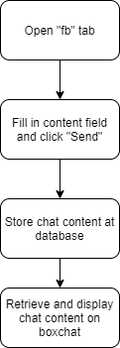

# Special Requirements

No special requirement.

# Preconditions

Content field is not empty.

# Postconditions

Chat content is display on global chatbox and all user can read it.

# Extension Points

No extension point.